CONTENTS

This module has the following files:
- MODULE_CLIENT_SIDE.doc
- MODULE_CLIENT_SIDE_MEDIA.zip

INTRODUCTION
In recent years internet has become our basic daily source and needs, enabling the dissemination of information in an inexhaustible content and interaction. Games uses has gained a prtominent role in nowadays computer usage, allowing people to get access to entertainment from any places.
You are asked to develop game called Phytons using HTML and CSS and develop client-side programming using JavaScript and its open source libraries. Some media files are available to you in a zip file. You can create more media and modify anything in the media if you want.
Your game needs to be developed in a tablet resolution (960x600 pixels). In bigger resolution, the game must be centred in the screen both horizontally and vertically.

DESCRIPTION OF PROJECTS AND TASKS
This is a module of 4 hours. Your first 2 hours must be used to create the design of the game in three PNG images and the initial layout using HTML/CSS. Your layout should follow the design that you created. The final 2 hours you will create the functionality of game using JavaScript that allows the game to work correctly in different web browsers.

Phytons game boards are describe below:
- Game Title
- Board are 960 x 600 with 48x30 grids
- Phytons which has 6 in length
- Player score
- Total time
- Rewind button

Design and Initial layout
- Deliver at least 3 PNG image files that present:
  - Game instruction: The first screen of the game presents the instructions to the player, a text field for player’s name, and the Play buttons for starting the game. The instructions for the game are included in the media files. The “Play” button should be disabled if the text field is empty.
  - Game board: It must present all elements described above in the game screen.
  - Game icon which represents the game immediately.
- Develop the initial markup (HTML + CSS) of your game application. Overall screen must be within 1024x1024 pixels.
- Buttons must have active and hover effects. The buttons background in hover state must be #5d96d4 and the active state must use #0069d9.
- The HTML and CSS code must be valid in the W3C standards for HTML5 and CSS3 rules in accordance with the WCAG and standard ARIA (Accessible Rich Internet Applications Suite)

Game Functionalities
- Show game icon on the top of the screen.
- Show game instruction in the centre after page are loaded.
- Show text field for player to input their name.
- Player can start game after click “Play” button at the bottom of game instruction.
- The “Play” button should be disabled if the text field is empty.
- Phyton’s starting point is in the middle of board and moving east (from left to right) automatically 4 grid per second. The phyton moves only north, south, east, or west.
- Phyton cannot move directly into opposite direction.
- To move phyton, player can use arrow keys or “WASD” keys with the following:
  - North with up arrow or ‘w’
  - South with down arrow or ‘s’
  - East with right arrow or ‘d’
  - West with left arrow or ‘a’
- Phyton should eat food pellet to increase its length which also increase player’s score.
- Pellet appear at random location inside board every 3 seconds and will disappear after 5 seconds. Number of pellets in board is minimum 3 and maximum 5 at the same time.
- Pellets cannot appear on python’s location.
- Player score are based on phyton’s length. So, the initial score would be 6.
- There’s a timer at the top of board whose shows elapsed time and player score.
- If phyton head hit board edge, then its head should appear on the opposite edge.
- Player can rewind the phyton game for 5 seconds. Rewind features allows player to rewind the game anytime they want.
- Rewind button are located at the bottom of game board, or player can activate it using “space” button.
- After the rewind feature activated, there will be a seeker in the form of slider which player can moves below the game board, the game will rewind accordingly. This seeker can be moved 5 ticks, each tick for each second.
- Player can cancel the rewind feature using “Cancel Rewind” button.
- Phyton dies if it hit its own tail. Game should notify player it is over and shows Highscore. If the current game score is higher, then it should be the highscore. Highscore should be saved.
- Your game should work without JavaScript errors or messages shown in the browser console.
- Maintain your HTML/CSS and JavaScript code organized and clean to facilitate future maintenance. Use correct indentation and comments. Use meaningful variable names and document your code as much as possible so another developer would be able to modify your work in the future.
- The game needs to work correctly in Google Chrome.

INSTRUCTION FOR COMPETITORS
- The media files are available in the ZIP file. You can modify the supplied files and create new media files to ensure the correct functionality and improve the application.
- Save your design files in a folder called "module_client_side/design".
- You should create additional images for each of the requested resolutions to highlight hidden elements, animations, interactions, or any additional information that will assist in the presentation of the game design.
- Additional file names
  - Instructions: province_instructions_2.png, XX_instructions_3.png
  - Game board: province_game_board_2.png, XX_game_board_3.png
- Save any image source files to a folder named "source" inside the "module_client_side/design" folder. The source files are the files that contain the design layers, development files, i.e. xd, psd, ai, or svg.
- Save the working game to the directory on the server named "module_client_side". Be sure that your main file is called index.html.
- You are responsible for the time management in your development. If you finalize some tasks you can continue to other tasks.

Example

These following images are for example purpose only. You may design your own game layout.

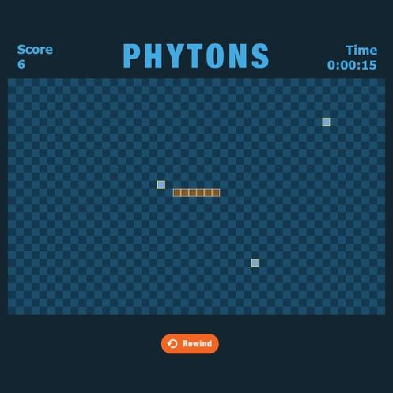
Image 1 Phyton example
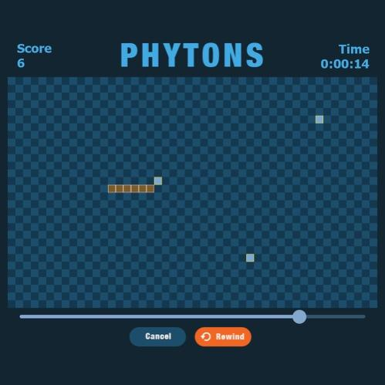
Image 2 Phyton Rewind Feature

